**Assignment 22.1:**

**Go through below blog and reiterate the same at your end.**

**https://docs.google.com/document/d/1csLBlMiEXs_hXWV2Z8VpBlrj_R6RoDQLlZUnA0uBT**

**Ck/edit**

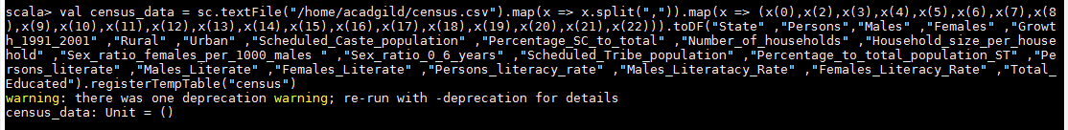

1. **val population = spark.sql("select state,sum(persons) as total_population from census group by state order by total_population desc").show**

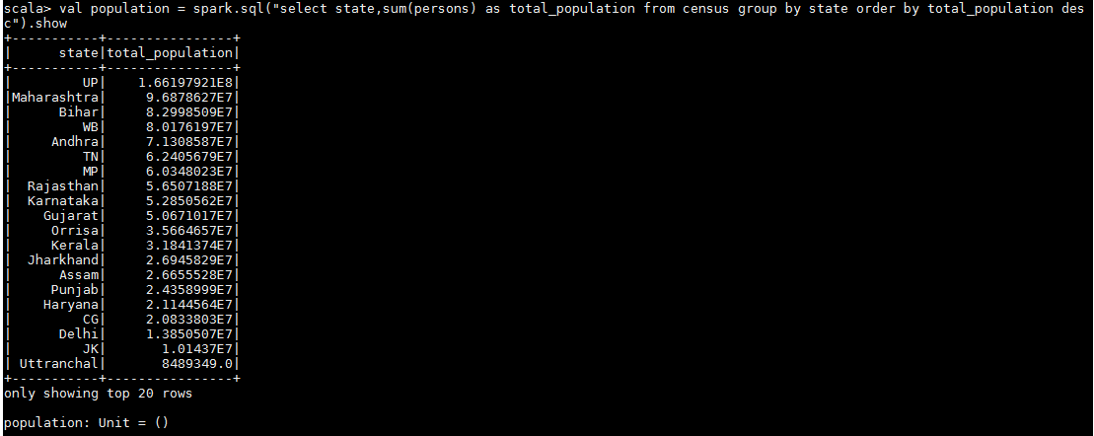

1. **val growth_rate = spark.sql("select state,avg(Growth_1991_2001) as total_growth from census group by state").show**

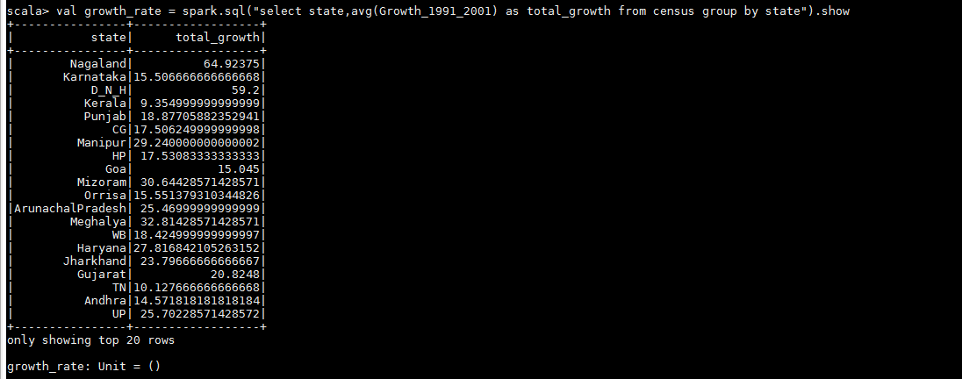

1. **val literacy = spark.sql("select state,avg(Persons_literacy_rate) from census group by state").show**

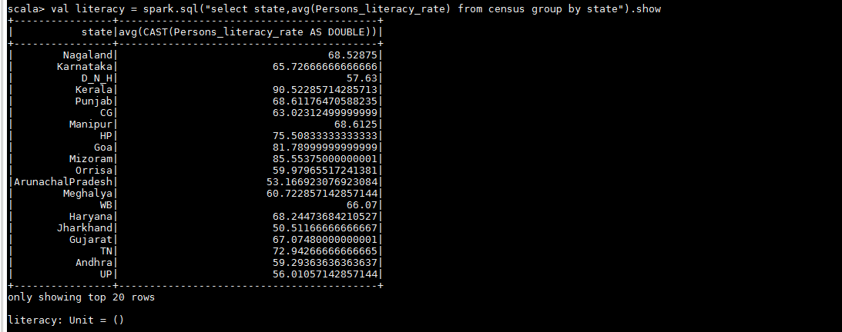

1. **val female_pop = spark.sql("select state, sum(Males)-sum(Females) from census group by state").show**

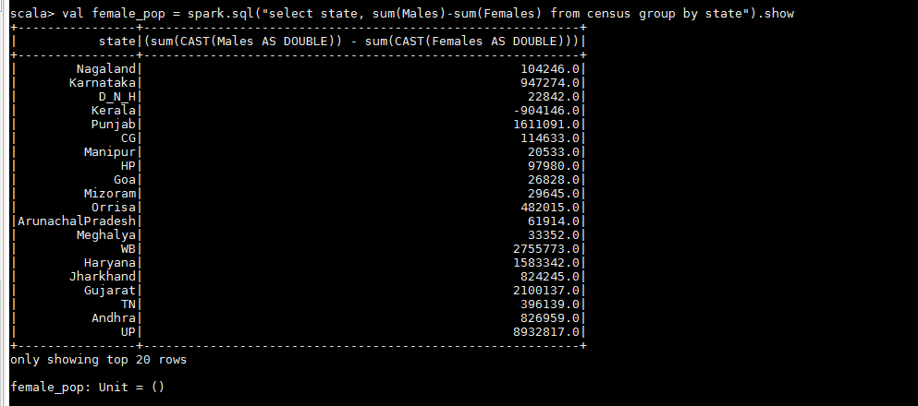

1. **val percenet_pop = spark.sql("select state, (sum(persons) * 100.0) / SUM(sum(persons)) over() as percent_pop_by_state from census group by state").show**

